[PSoC 4 Pioneer Kit Community Project#01 - Blinking LED](http://www.element14.com/community/message/75399#75399/l/psoc-4-pioneer-kit-community-project01--blinking-led)

To kick-start our ***100 Projects in 100 Days*** community effort around the PSoC 4 Pioneer Kit, today I'm posting a simple "Blinking LED" project.

This is a very simple project that will help you get started with your first design for the PSoC 4 Pioneer Kit.

Project Schematic:

[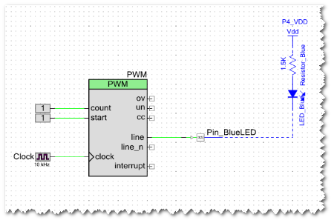](http://www.element14.com/community/servlet/JiveServlet/showImage/2-75399-143842/01+-+Blinking+LED+Sch.png)  
                    Actual screenshot from PSoC Creator schematic (TopDesign.cysch)

In this design, a PWM Component drives the Pin Component which is connected to the Blue LED on the Pioneer Kit. The PWM modulates to make the blue LED blink at regular intervals

Hardware connections on the Kit:

* Blue LED - P0[3] (this is internally wired, no extra connections required)

Software Setup:

* See steps #1 - #6 from the main post [here](http://www.element14.com/community/message/75417#75417/l/100-projects-in-100-days)

Project Files:

* Blinking LED.cywrk.Archive01.zip

<http://www.element14.com/community/message/75399>